Sprint-3

|  |  |
| --- | --- |
| Team ID | PNT2022TMID24032 |
| Project Name | Smart Fashoin Recommender Application |
| Team Membes | Md Umraz Sheriff  Aravind  Basheer Ahamed  Md Nawfal |

1. Create a Bucket in IBM object storage.

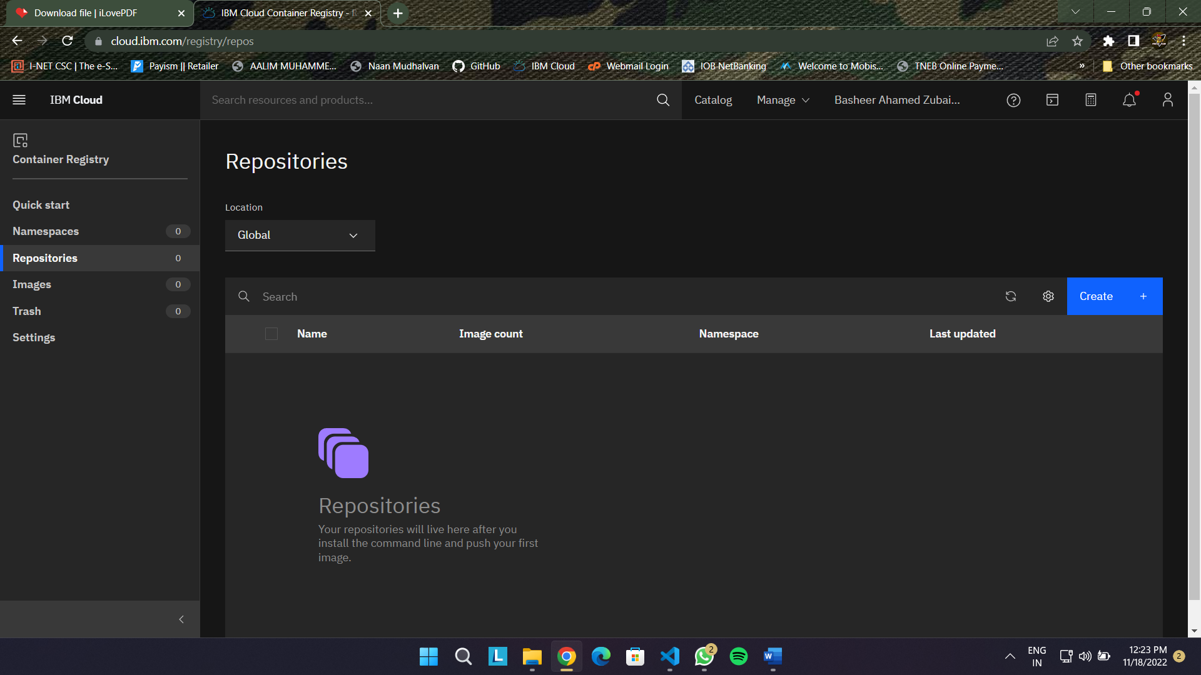

1. Upload an 5 images to ibm object storage and make it public. write html code to displaying all the 5 images.

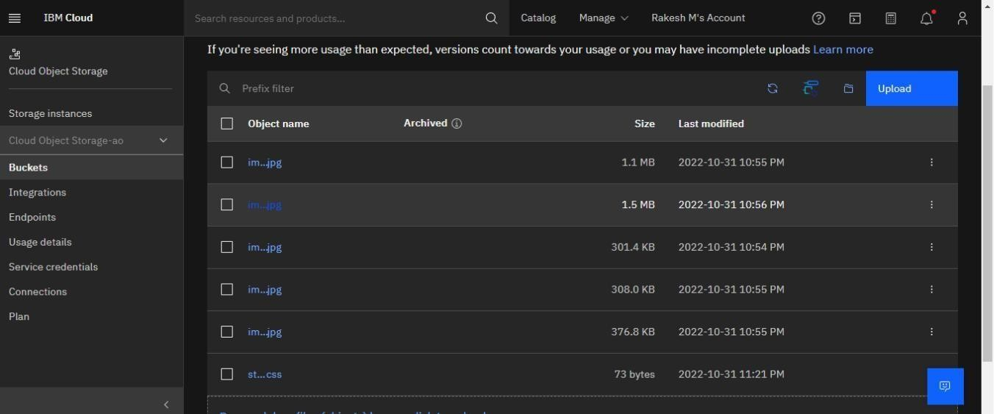

# Assignment3.html

<! DOCTYPE html>

< html lang="en">

< head>

<meta charset="UTF-8">

<meta http-equiv="X-UA-Compatible" content="IE=edge">

<meta name="viewport" content="width=device-width, initial-scale=1.0">

<title>Document</title>

<link rel="stylesheet" href="https://rakesh87.s3.us-east.cloud-object- storage.appdomain.cloud/style.css ">

< /head>

< body>

<img src="https://rakesh87.s3.us-east.cloud- objectstorage.appdomain.cloud/img1.jpg " alt="">

<img src="https://rakesh87.s3.us-east.cloud- objectstorage.appdomain.cloud/img2.jpg " alt="">

<img src="https://rakesh87.s3.us-east.cloud- objectstorage.appdomain.cloud/img3.jpg " alt="">

<img src="https://rakesh87.s3.us-east.cloud- objectstorage.appdomain.cloud/img5.jpg " alt="">

<img src="https://rakesh87.s3.us-east.cloud- objectstorage.appdomain.cloud/img4.jpg " alt="">

< /body>

< /html>

# Upload a css page to the object storage and use the same page in your HTML code.

Style.css

img{

text-align: center;

height:250px;

width:250px;

}

# Assignment3.html

<!DOCTYPE html>

<html lang="en">

<head>

<meta charset="UTF-8">

<meta http-equiv="X-UA-Compatible" content="IE=edge">

<meta name="viewport" content="width=device-width, initial- scale=1.0">

<title>Document</title>

<link rel="stylesheet" href="https://rakesh87.s3.us-east.cloud-object-

storage.appdomain.cloud/style.css">

</head> <body>

<img src="https://rakesh87.s3.us-east.cloud-object storage.appdomain.cloud/img1.jpg" alt="">

<img src="https://rakesh87.s3.us-east.cloud-object storage.appdomain.cloud/img2.jpg" alt="">

<img src="https://rakesh87.s3.us-east.cloud-object storage.appdomain.cloud/img3.jpg" alt="">

<img src="https://rakesh87.s3.us-east.cloud-object storage.appdomain.cloud/img5.jpg" alt="">

<img src="https://rakesh87.s3.us-east.cloud-object storage.appdomain.cloud/img4.jpg" alt="">

</body>

</html>

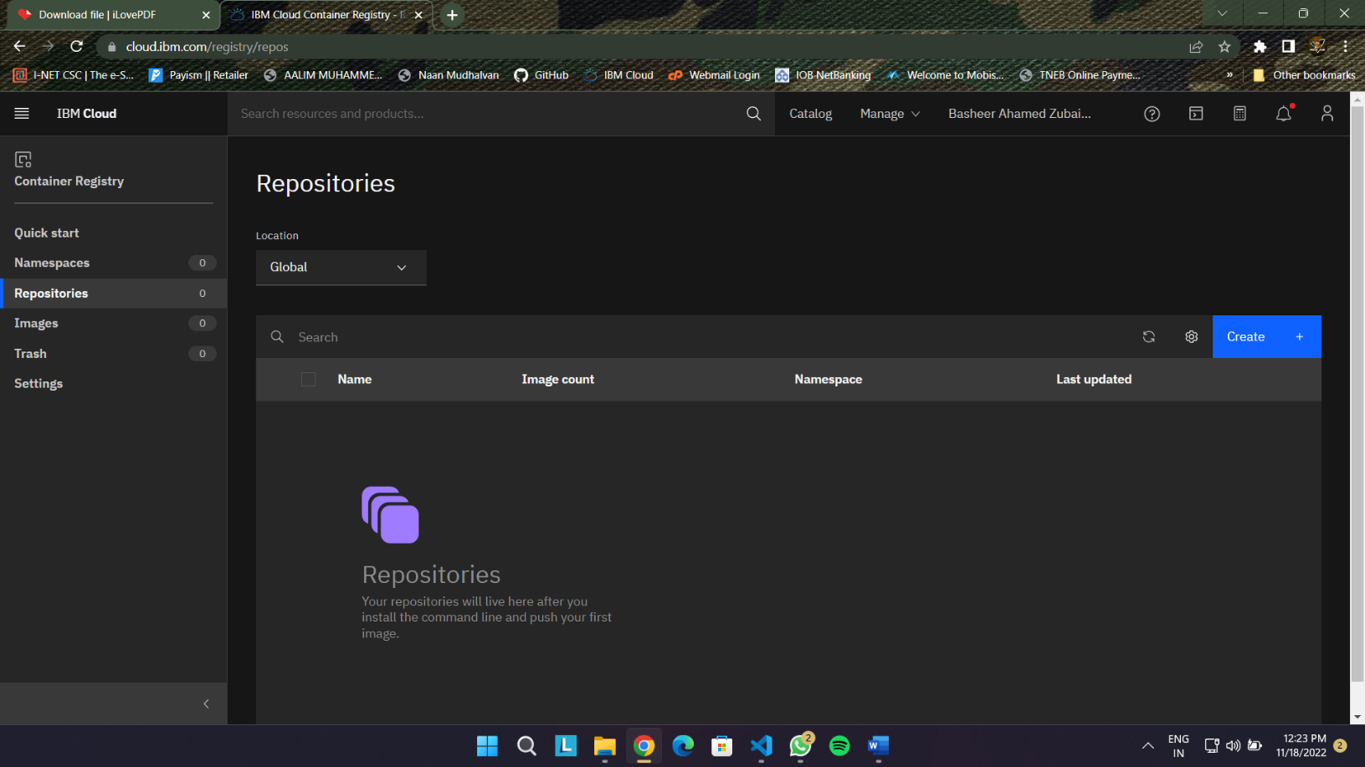

# Design a chatbot using IBM Watson assistant for hospital. Ex: User comes with query to know the branches for that hospital in your city. Submit the web URL of that chat bot as a assignment.

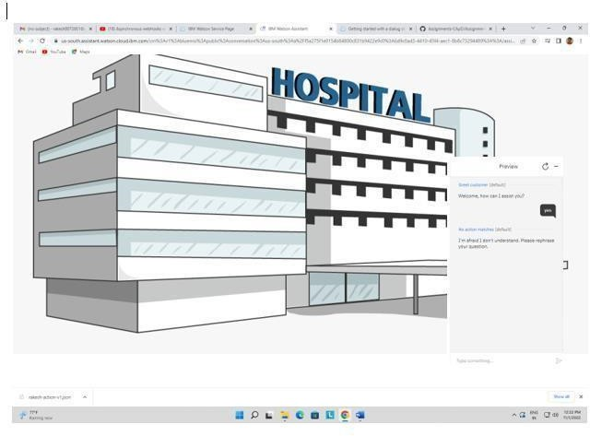

1. Create Watson assistant service with 10 steps and use 3 conditions in it. Load that script in HTML page.

